Towable electric scissor lift：
The main structure of the Towable electric scissor lift is made of high-strength manganese steel rectangular tube, which is high in strength and durable. The Towable electric scissor lift consists of a base, a boom and a workbench. The base is welded by the corresponding strength steel plate; the arm frame is a shearing hinge type vertical lifting. The Towable electric scissor lift features a fall protection safety system that prevents the pipe from bursting. There is a manual drop valve that is lowered in emergency when power is cut off. The refined hydraulic cylinder block and imported seals ensure good sealing performance of the cylinder. The height of the Towable electric scissor lift is between 900mm and 1200mm, and the height of the guardrail can be selected by the customer. The Towable electric scissor lift can also be equipped with a manual hydraulic unit that can be lifted and lowered as usual in a power outage or no power supply, and can be extended to the desired position when the length of the platform is insufficient, thereby increasing work efficiency.
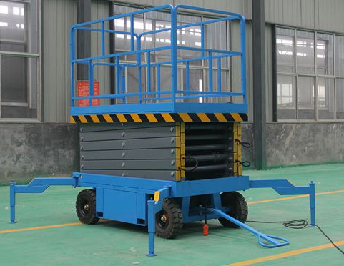
Load capacity: 300kg-2000kg
Max. Lifting Height：18m
Lifting speed:
4-6m/min
Power:
AC&DC choice
Electric hydraulic model

Towable electric scissor lift parameter table:
Model | Lifting height | Load capacity | Working table | Size | Power | Weight
 | m | KGS | mm | mm | KW | KGS
SJY0.3-4 | 4 | 300 | 1640*900 | 2150*1200*1000 | 1.5 | 480
SJY0.3-6 | 6 | 300 | 1640*900 | 2150*1200*1150 | 1.5 | 650
SJY0.5-6 | 6 | 500 | 1640*900 | 2200*1200*1290 | 2.2 | 750
SJY0.5-6B | 6 | 500 | 1640*900 | 2100*1500*1400 | 2.2 | 750
SJY1-6 | 6 | 1000 | 1700*1200 | 2150*1200*1350 | 2.2 | 950
SJY0.3-8 | 8 | 300 | 1750*900 | 2150*850*1400 | 2.2 | 900
SJY0.5-8 | 8 | 500 | 1800*1200 | 2200*1500*1350 | 2.2 | 1000
SJY0.5-8B | 8 | 500 | 1750*900 | 2150*1200*1350 | 2.2 | 900
SJY1.0-8 | 8 | 1000 | 2000*1200 | 2400*1500*1530 | 2.2 | 1500
SJY0.3-10 | 10 | 300 | 2100*1200 | 2500*1500*1530 | 2.2 | 1300
SJY0.5-10 | 10 | 500 | 2100*1200 | 2500*1500*1530 | 2.2 | 1400
SJY1.0-10 | 10 | 1000 | 2200*1300 | 2650*1600*1740 | 3.0 | 2200
SJY0.3-9 | 9 | 300 | 1800*1200 | 2200*1500*1450 | 2.2 | 950
SJY0.3-11 | 11 | 300 | 2100*1200 | 2600*1500*1650 | 2.2 | 1850
SJY0.3-12 | 12 | 300 | 2550*1500 | 2950*1950*1740 | 3.0 | 2200
SJY0.5-12 | 12 | 500 | 2550*1500 | 3000*1950*1850 | 3.0 | 2350
SJY1.0-12 | 12 | 1000 | 2600*1500 | 3200*2000*2130 | 3.0 | 3000
SJY0.3-14 | 14 | 300 | 2990*1500 | 3250*1950*1970 | 3.0 | 2900
SJY0.5-14 | 14 | 500 | 3050*1500 | 3300*2000*1970 | 3.0 | 3000
SJY1.0-14 | 14 | 1000 | 3050*1600 | 3400*2200*2300 | 3.0 | 3600
SJY0.3-16 | 16 | 300 | 3150*1600 | 3600*2000*2300 | 3.0 | 3650
SJY0.5-16 | 16 | 500 | 3200*1600 | 3600*2000*2300 | 3.0 | 3900
SJY0.3-18 | 18 | 300 | 3150*1800 | 3700*2100*2500 | 3.0 | 4500
SJY0.3-20 | 20 | 300 | 3400*1800 | 3800*2100*2500 | 3.0 | 4900

Towable electric scissor lift maintenance:
1.Towable electric scissor lift When using about 2 months (according to the actual frequency of use), it is necessary to fill the rotating part with grease once;
2. Regularly check the working state of the pin shaft every month. If the pin shaft and the screw are loose, be sure to tighten it to prevent the shaft pin and the screw from falling off.
3. The hydraulic oil should be kept clean and replaced every 6 months;
4. When servicing and cleaning the lifting platform, be sure to support the safety poles.

Why did you choose our towable electric scissor lift?
DFLIFT is located in the “China Hydraulic Lift Home” National Hydraulic Lift, Lift Freight Elevator, Lifting Platform Manufacturing Base, Xinxiang Economic Development Zone, Henan Province. The company is a professional and modern enterprise integrating R&D, production and sales, management specifications and equipment. Excellent, strong technology, advanced technology, perfect testing technology, high modern management level and strong design and production capacity in the same industry.

